
The Encryption System
By
Mathabela Prinance 240739191
Zakwe Siyanda 221676880
Lindokuhle Qwela 222583649
Luthuli Samukelisiwe 240396286
Makaya Sibongile Portia 240472896
Subject:
SOFTWARE DESIGN 2
Qualification:
BET In the COMPUTER ENGINEERING
Faculty of Engineering
Department of Electronic, Electrical and Computer engineering
At the
CAPE PENINSULA UNIVERSITY OF TECHNOLOGY
Lecturer: S EKWE

Table of Contents
Contents
Table of Contents 1
Table of Figures 2
Introduction 3
Problem Definition 3
System Designs and Diagrams 3
Implementation Highlight 4
Testing and Evaluating 5
GA2 and GA7 Reflection 5
Team Contribution Breakdown 5
Conclusion 5
References 6

Table of Figure
Figure 1UML Diagram of the Encryption System 4
Figure 2 Control Statements 5
Figure 3 Exceptions, Comments and File Handling 5
Figure 4 Symmetric key Diagram 5
Figure 5 Data before Encryption 6
Figure 6 Data after Encryption 6

Introduction

The report discusses the creation of a solution, outlining the approach and evaluating the outcomes of the Encryption System intended to enhance the confidentiality of a user’s sensitive information and data online.

Problem Definition
These days, data security is a difficult problem that affects many domains, such as communication and computing. Rapid technological advancement has resulted in cyber security attacks that compromise security algorithms and compromise user data confidentiality and authentication. This project creates an access key (cryptographic key) to encrypt and decode data so that only authorized users may see and use it, protecting user data and personal information. (Bhanot and Hans, 2015)
This allows users to have a safe and protected environment of their information in computers and communication around the internet.

System Designs and Diagrams
To obtain the private key or keys, the user might build a profile on the system. The generated keys are kept in the file with the same name and location as the encrypted file. The keys are kept in a way that prevents the user from encrypting and decrypting simultaneously; instead, they must exit before decrypting. The system enables users to view, write, and edit files when they are given access. This protects the user's private data and sensitive information from unauthorized users.

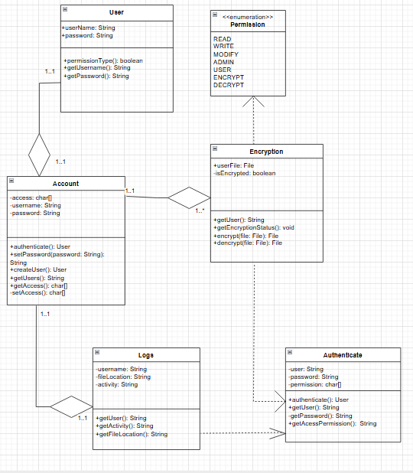
Figure 1UML Diagram of the Encryption System
- This class handles user information by retrieving the user's name and password using the getUsername and getPassword methods.

- To generate an encryption key and encrypt and decode data, this class requires the constructor of the User class, which it inherits.

- This class uses the getFileLocation function to obtain the file's location so that encryption may be performed on it.

- This class checks whether the file was encrypted or not using the getEncryptionstatus method; if not, encryption is carried out using the encrypt and decrypt methods.

- This class verifies before granting user access. It ensures that only authorized users have access by verifying that the password entered matches the one that is configured to enable encryption.

Implementation Highlight
The system is XOR Encryption and uses java. The system is designed to have File handling to read and write information from a file that will be encrypted and decrypted, exceptions for error handling, preventing the system from crashing and not performing to the users’ expectations. It has OOP where each class handles a specific duty for encryption and decryption logic, each with objects helping the classes to be executed in the main function. It also uses Control structures (if else statements), to control the conditions and flow of the system.
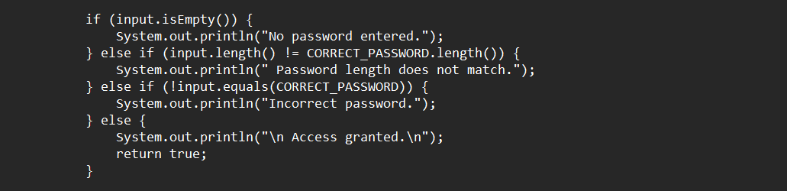
Figure 2 Control Statements
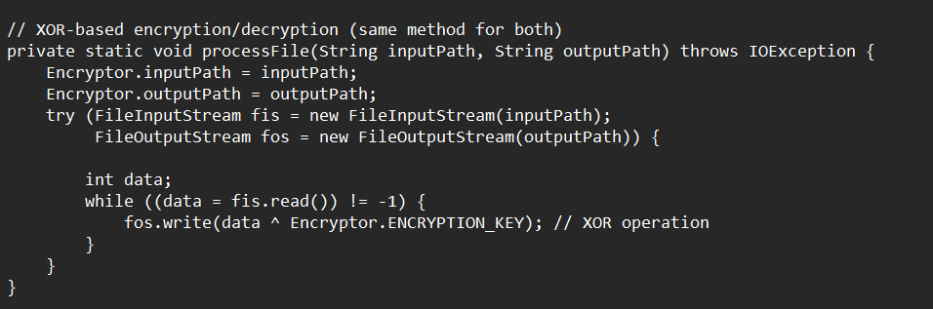
Figure 3 Exceptions, Comments and File Handling
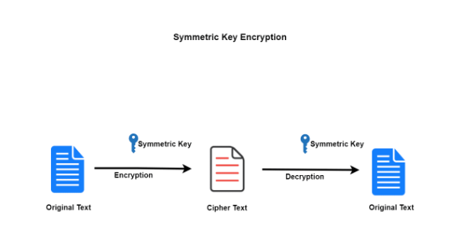
Figure 4 Symmetric key Diagram

Testing and Evaluating

Testing
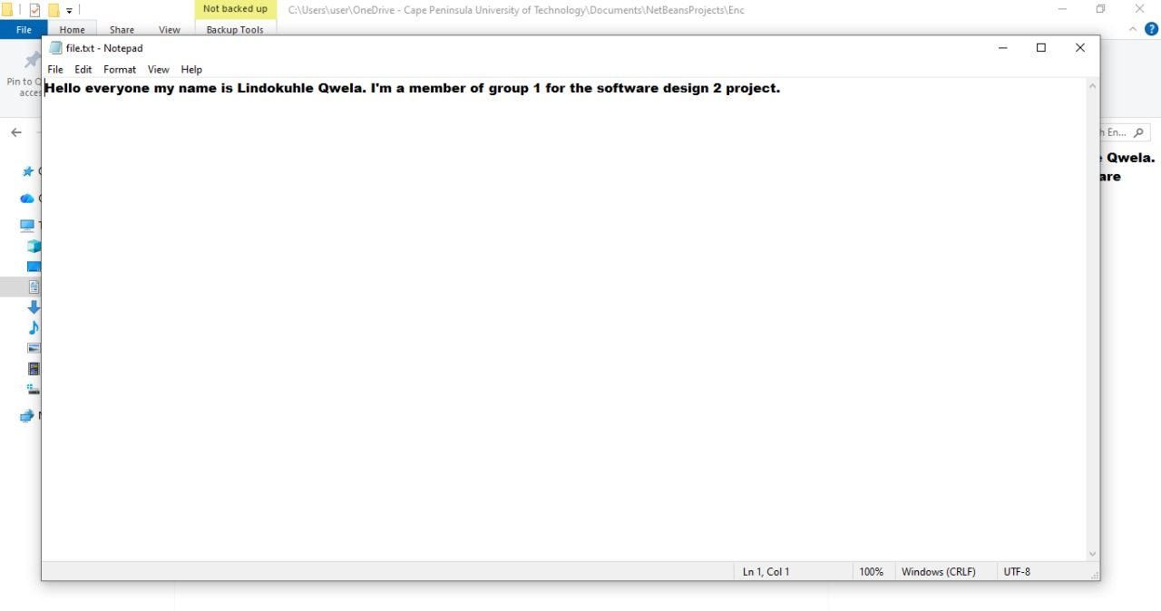
Figure 5 Data before Encryption
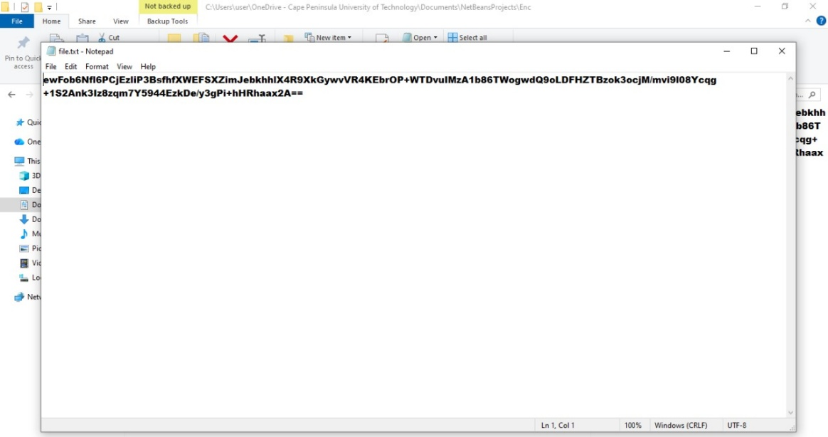
Figure 6 Data after Encryption

Evaluating
A symmetric(Lindo) key was established, and text was written to a file to evaluate the system's performance. Following the testing, the text was identical before encryption and after decryption. Symmetric and asymmetric key algorithms differ in whether the same key is utilized for encryption and decryption. For both data encryption and decryption, the symmetric-key technique employs the same key. (Nie, Zhou and Lu, 2014)

GA2 and GA7 Reflection

GA2
The variables, strings, OOP, and exceptions make up the encryption project. Information about the user was stored in the variables String name and String surname for the user profile. These are the programming ideas that were covered in the second course on software design.

GA7
XOR has special benefits in the blockchain context when compared to conventional encryption techniques. It is becoming an essential part of blockchain security architecture due to its lightweight nature, which triples encryption speed, and its efficiency, simplicity, and absolute confidentiality.

Team Contribution Breakdown
- Program Developers: Responsible for programming, debugging & fine tuning the program for smooth operation. – Lindokuhle Qwela & Siyanda Zakwe
- Researcher: Focuses on the information needed to develop the program, which may include researching how certain encryption algorithms work & which is the best choice for developing the program. – Mathabela Prinance
- Tester: Tests on whether the software operates as intended, whether the program can encrypt and/or decrypt a certain file. – Sibongile Portia Makaya
- Documentation: Document all project research, findings, and creates a neat report of everything that was used in developing this program. – Samukelisiwe Luthuli

Conclusion
The encryption system successfully carries out encryption and guarantees the protection of a user's private data. Future enhancements might involve manually encrypting files stored in the cloud or implementing two-step verification for increased security, among other things.

References
Bhanot, R. and Hans, R., 2015. A review and comparative analysis of various encryption algorithms. International Journal of Security and Its Applications, 9(4), pp.289-306.
Nie, T., Zhou, L. and Lu, Z.M., 2014. Power evaluation methods for data encryption algorithms. IET software, 8(1), pp.12-18.
https://www.gate.com › blog

